Walking the Talk
Business in the Community’s values commit us to be focused, passionate, pioneering, collaborative, and to act with integrity. We strive to ensure that what we do internally is aligned to the asks that we make of our members. Walking the talk is fundamental to all we do. ‘Walk the Talk’ is our internal terminology for our work in this area.
Environmental Sustainability
At Business in the Community NI we want to ensure that all actions we take are done with environmental sustainability in mind. Internally Business in the Community makes its commitment to the environment with leadership from the Senior Management team delivered through the Eco Team. The Eco Team have introduced an Environmental Policy and a range of initiatives to have a positive impact on the environment, some of these are outlined below. We have an Environmental Management System certified to BS8555 Phase 3.

NI ENVIRONMENTAL BENCHMARKING SURVEY. BITCNI have achieved GOLD in the Survey since 2015.

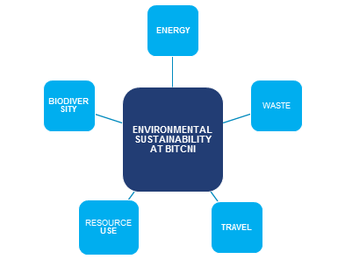
To reduce and manage our environmental impact we have introduced the following initiatives:
Energy Management
- Switch off Policy for lights and electrical equipment
- Monitoring of electricity and gas consumption
- Upgraded all lighting in the Belfast office to LEDs
- Removed the server and moved to the Cloud
Waste Management
- No desk bins
- We have recycling facilities for:
  - Plastic
  - Paper
  - Cardboard
  - Metals
  - Organic/food waste
  - Glass
  - Batteries
  - Toner cartridge’s
  - IT equipment
Travel
- Financial incentive for car sharing for business travel
- Financial incentive for bicycle miles for business travel
- Cycle to work scheme and season loan tickets for public transport available to staff
- Flexible working available
- Virtual meetings encouraged (Microsoft Teams & Zoom installed on all PCs)
- Business travel - car, air, bicycle and car sharing miles - monitored
Resource Use
- We are developing an Environmental Procurement Policy
- Major investment in IT equipment such as Surfaces, iPhones, laptops
- Introduction of Office 365 and it’s tools including SharePoint, CRM and Teams which reduce the need to print
- Purchase from local suppliers where possible
- Energy efficient equipment purchased
- FSC certified paper purchased and paper consumption monitored
Biodiversity
- Bridge Community Garden opened in 2014
- Native trees and plants in the garden

Key Achievements in 2020/21*
All of our staff have been working from home since March 2020, as a result there has been no commuting to and from the office. The electricity, oil and gas consumption in the offices has been reduced while unoccupied, and there was reduced waste production and water usage during that period.
65%
Electricity consumption reduction from 2018/19
0kgs
Waste generated in the office (office closed for period)
93%
Reduction in business miles travelled per employee
98%
Reduction in paper consumption from 2018/19
11
Of our staff members are certified as ‘Carbon Literate’

7571KWH OF RENEWABLE ENERGY GENERATED
*Reporting period BITCNI Financial Year July 2020 – June 2021

