**ENVIRONMENTAL POLICY**

Business in the Community is a business-led charity focused on promoting responsible business practice. With 210+ members, we are the largest business-led coalition dedicated to corporate responsibility. Our purpose is to challenge and support business to be a force for good.

We have developed an Environmental Management System (EMS) in line with BS8555:2016 (phases 1-3) which is externally inspected every year.

We address our environmental management aims by setting formal environmental objectives and targets, working to an environmental action plan, and implementing documented green office procedures.

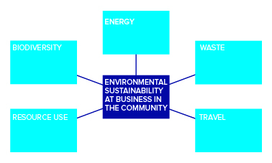

We are fully committed to the protection of the environment through the following actions:

* The prevention of pollution
* Fulfilment of our compliance obligations
* Continual improvement of our EMS to enhance environmental performance.

Our EMS operates with the involvement of both management and staff. Business in the Community’s Environment Team continually manages and improves the environmental impact of the organisation by engaging employees on environmental initiatives and through regular audits. The Environment Team reports to the Senior Management Team and the BITC Board which ensures the Environmental Management System remains effective. Business in the Community also promotes the environment as an integral aspect of our corporate responsibility.



**Kieran Harding**  
Managing Director  
30 June 2021 (to be reviewed June 2022)