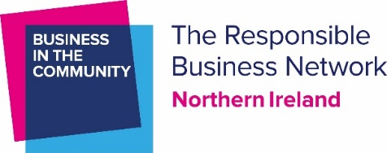

Nomination Form
GEORGE DAWSON AWARD

Background
The George Dawson Award for Environmental Contribution was established in 2008 and pays tribute to the memory of George Dawson, former Business in the Community colleague and Director of ARENA Network. George passed away in 2007, following a short illness.

During his nine years with Business in the Community, George developed the ARENA Network, a programme established to coordinate all business environmental initiatives in Northern Ireland and to provide an environmental support service for local business.

Those who knew George and had the opportunity to work with him are all the richer for the experience and greatly miss his contribution, commitment and sense of humour.

The Award
This award is designed to recognise and celebrate a significant contribution, made by a nominated businessperson, to improving the environmental performance and impacts of his or her organisation upon the environment and wider community. The award recognises those from a corporate background, as opposed to someone who works for an environmental organisation.
For example, someone who:
- Is seen as an environmental leader or champion, both within and outside of his or her organisation
- Leads by example and inspires others
- Raises environmental awareness, both internally and within the wider community
- Has introduced innovative solutions to environmental challenges across the company
- Significantly decreases the environmental impacts and/or cost savings for the organisation
- Undertakes environmental actions above and beyond the call of duty
- Offers support and guidance to other organisations

Nomination procedure
If you have worked with someone over the last year who you would like to nominate for the George Dawson Award for Environmental Contribution in 2022, please complete this nomination form and return to environment@bitcni.org.uk by 12:00pm on Thursday 13 October. Please do not mention your nomination to the individual concerned at this stage.

Tell us about the person you would like to nominate:
Name of your nominee
Job title
Name and address of the organisation they work for

Why do you think they deserve this award?
(max 300 words):
How do they ‘walk-the-talk’ outside their official role?
(max 200 words)

Tell us about you:
Your name
Your organisation and job title
Your work phone number
Your mobile phone number
Your e-mail address
Name and address of your organisation
How do you know the nominee

What happens next?
Nominations will be evaluated by a small panel of Business in the Community stakeholders. The winner will be announced at the 2022 NI Environmental Benchmarking Survey results launch on Thursday 17 November 2022.

Closing date: Please return your completed form to environment@bitcni.org.uk by noon on Thursday 13 October 2022. All nominations will be treated in the strictest confidence.

